JECRC 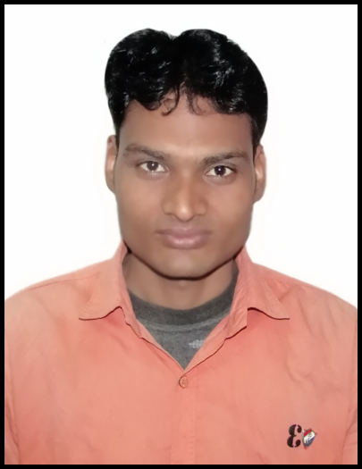
JAIPUR

INDIVIDUAL FACULTY DATA SHEET
Name of the faculty member | : | HUKAM CHAND
Present Designation | : | ASSISTANT PROFESSOR
Email Id: hukamchand.me@jecrc.ac.in
Contact Details: 9001484123

I. Particulars of Educational Qualification: (only completed)

Category | Name of the Degree | Specialization | Year of Passing | Name of the College | Name of the University
UG | B.TECH | MECHANICAL ENGG. | 2012 | RCERT,JAIPUR | RTU, KOTA
PG | M.TECH | THERMAL ENGG. | 2017 | JAGANNATH UNIVERSITY JAIPUR | JAGANNATH UNIVERSITY JAIPUR
Ph.D.

II. Academic Experience : Teaching assistant in JECRC JAIPUR from 23rd july 2012 to
Till now.
III. Industrial Experience :

IV. Title of Ph.D. Thesis :

V. Awards/Achievements :

VI. Research/Specialization :

VII. Course Taught :

VIII. Refereed International Journal Publication :

IX. International Conference Proceeding :

X. Books Written :

XI. M.Tech Thesis Guide :

XII. PHD Thesis Guide :

XIII. Professional Body Membership :

